Touro University Graduate School of Technology
Course: Network Security
Instructor: A. Polyakov
Name: Md Azizul Rahaman
Activity 3-1: Identifying New Computer Viruses and Worms
Step 1: Open Wikipedia
I started my web browser and went to https://en.wikipedia.org to research current ransomware and virus threats. From the search bar on the top right, I typed “Ryuk (ransomware)” and opened the related article to begin the research.
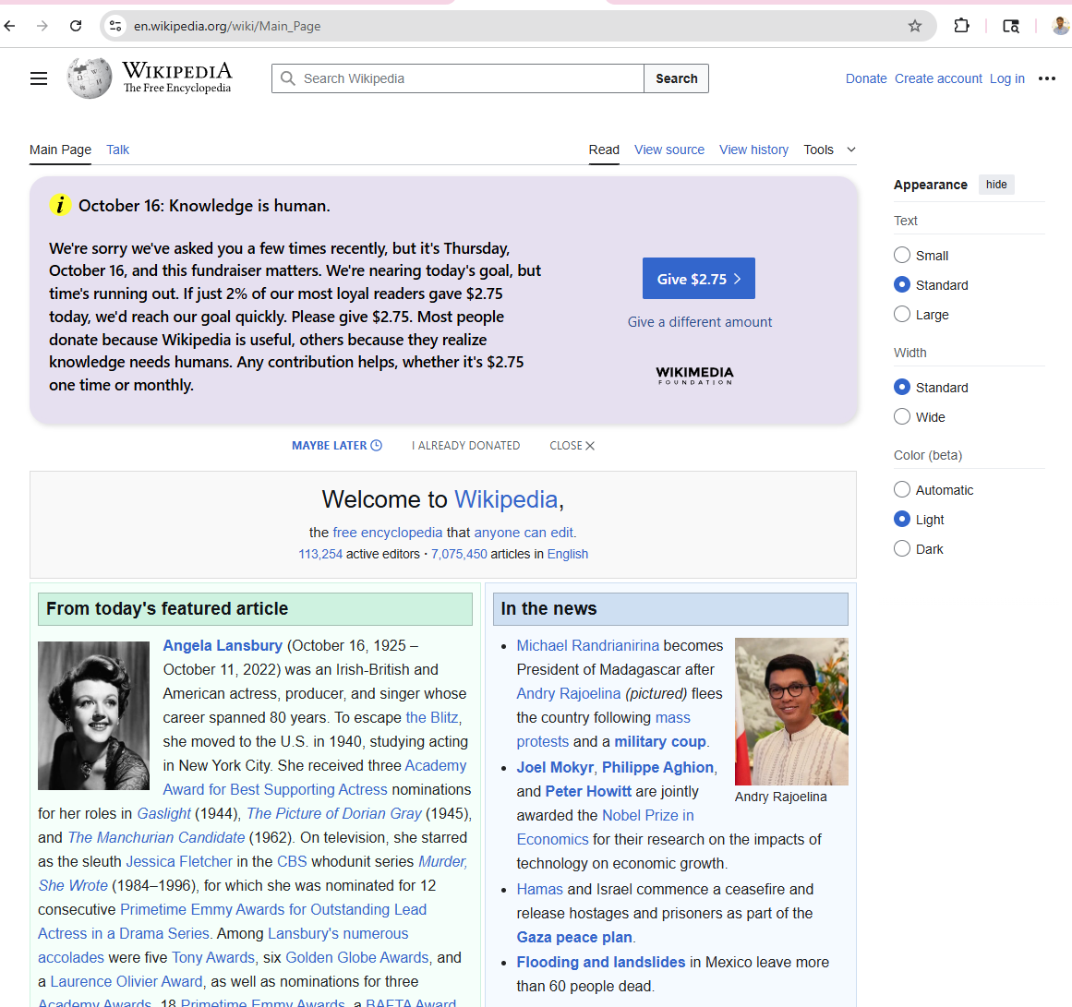

Step 2: Country of Origin of Ryuk Ransomware
According to the Wikipedia article on Ryuk ransomware, this malware is believed to have originated from Russia or Russian-based cybercriminal groups. Earlier reports linked it to North Korea, but newer analysis by multiple security researchers points to Russian threat actors.
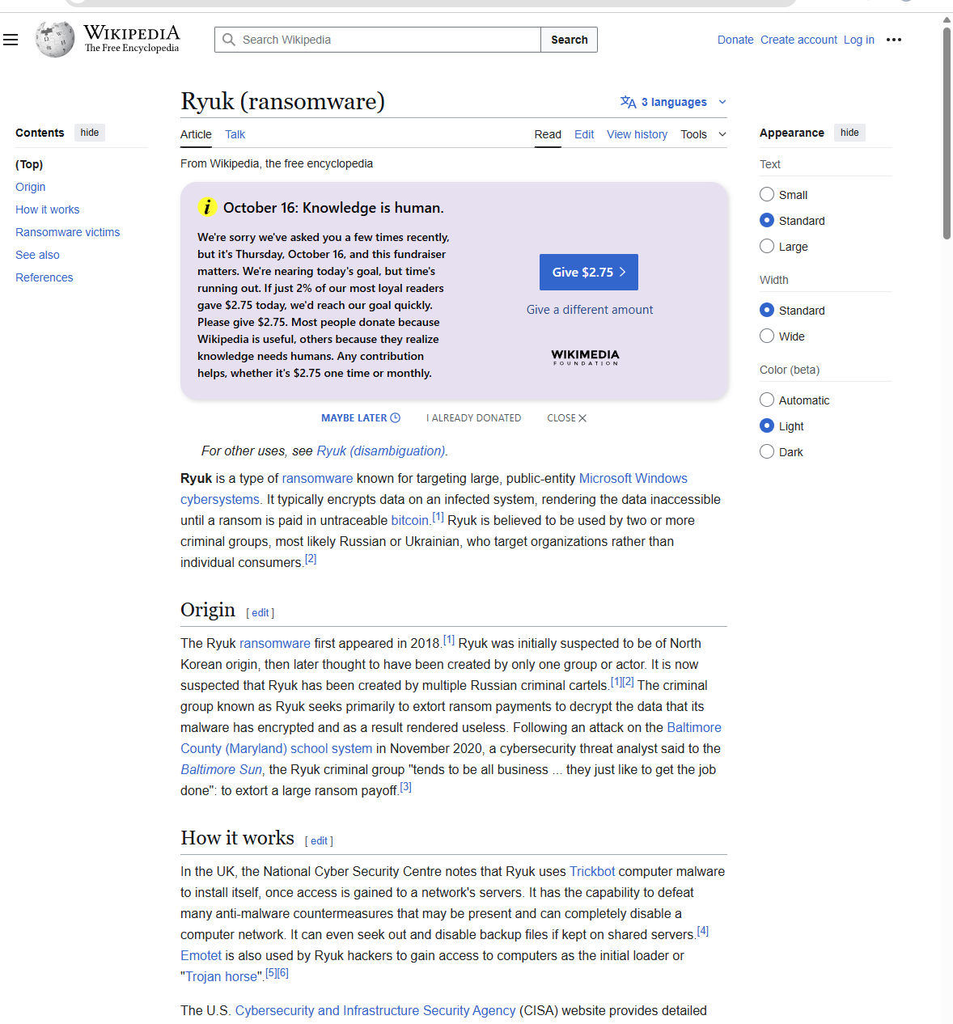

About Ryuk Ransomware
Ryuk is a ransomware family first discovered in 2018. It targets high-profile organizations by encrypting critical data and demanding ransom payments, often in Bitcoin. Researchers have linked Ryuk to earlier variants such as Hermes 2.1, and its victims include hospitals, media companies, and infrastructure providers.
How Ryuk Works:
- Spreads via phishing emails carrying malicious Microsoft Office attachments.
- Uses Emotet and TrickBot as loaders to establish network access.
- Deletes shadow copies and disables System Restore to prevent recovery.
- Encrypts both local and network drives.
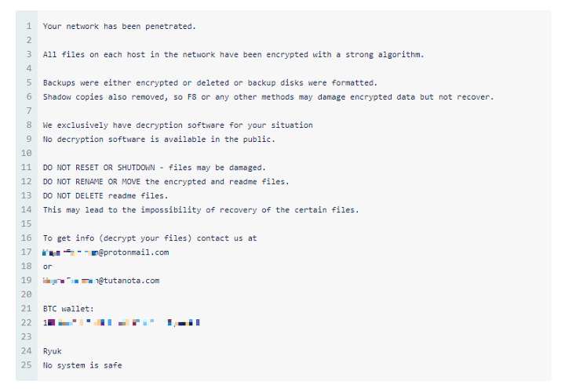
Step 3: Description and Protection from Ryuk Ransomware
Ryuk is a highly targeted ransomware that encrypts important files on company networks and demands ransom in Bitcoin for decryption. It often enters systems through phishing emails or through loader malware such as TrickBot and Emotet. Once active, it disables security tools, deletes backups, and encrypts all drives including network shares.
Protection Methods:
- Maintain offline, verified backups of all critical data.
- Provide user training on phishing and malicious attachments.
- Install and update endpoint security software regularly.
- Use network segmentation and least-privilege access.
- Apply security patches frequently.
- Deploy SIEM/IDS for early detection and incident response.
- Enable anti-ransomware and rollback features in endpoint protection tools.
- Stay informed about emerging ransomware campaigns.
How can I protect myself against Ryuk?
The first step in protecting against any ransomware attack is to invest in anti-malware/antivirus protection, preferably one that offers real-time protection designed to thwart advanced malware attacks such as ransomware. You should also look out for features that will both shield vulnerable programs from threats (an anti-exploit technology), as well as block ransomware from holding files hostage (an anti-ransomware component). Some anti-malware solutions offer rollback technology, especially designed to counter the effects of ransomware.
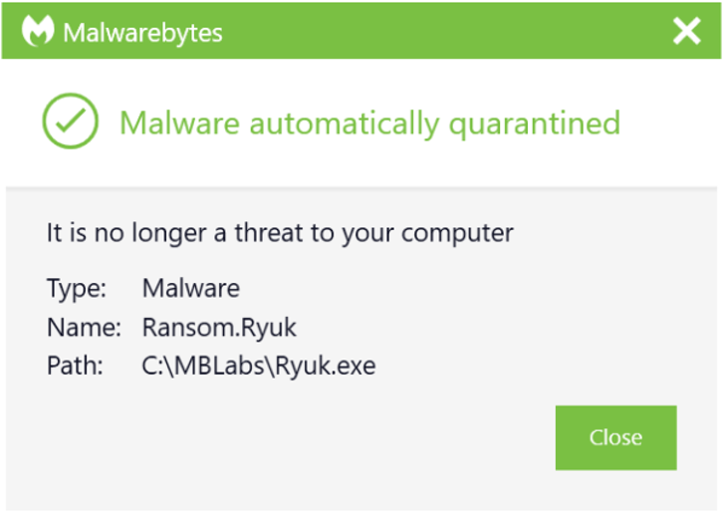Malwarebytes blocks Ransom.Ryuk
Next, create secure backups of your data on a regular basis. Use cloud storage that includes high-level encryption and multi-factor authentication. Another option is to purchase USBs or an external hard drive where you can save new or updated files—just be sure to physically disconnect the devices from your computer after backing up, otherwise they could become infected with ransomware too.
Make sure your systems and software are updated regularly. The WannaCry ransomware outbreak took advantage of a vulnerability in Microsoft software, and while the company had released a patch for the security loophole, many folks didn't install the update which left them open to attack. Enable automatic updating to stay on top of security patches.
Finally, stay informed. One of the most common ways that computers are infected with ransomware is through social engineering. Educate yourself (and your employees if you're a business owner) on how to detect phishing emails, suspicious websites, and other scams. Exercise common sense if it seems suspect, it probably is.
How can I remove Ryuk?
You can use the Malwarebytes Anti-Malware Nebula console to scan your endpoints. Choose the Scan + Quarantine option. Afterwards, you can check the Detections page to see which threats were found. On the Quarantine page you can see which threats were quarantined and restore them if necessary. Take a close look at the Detections page to see if you can find the answer to how Ryuk was delivered. You do not want to leave any backdoors behind that the attackers can use again!
If you suspect the delivery of Ryuk has been carried out by Emotet, you will need to perform some extra steps. If your computer is connected to a network—isolate it immediately. Once isolated, make sure you patch and clean the infected system. But that’s not all. Because of the way Emotet spreads across your network, a clean computer can be re-infected when plugged back into an infected network. Clean each computer on your network one-by-one. It’s a tedious process, but Malwarebytes business solutions can make it easier, isolating and remediating infected endpoints and offering proactive protection against future Emotet infections.

Step 4: Visit McAfee Enterprise Threat Center
Next, I opened www.mcafee.com/enterprise/en-ca/threat-center.html.
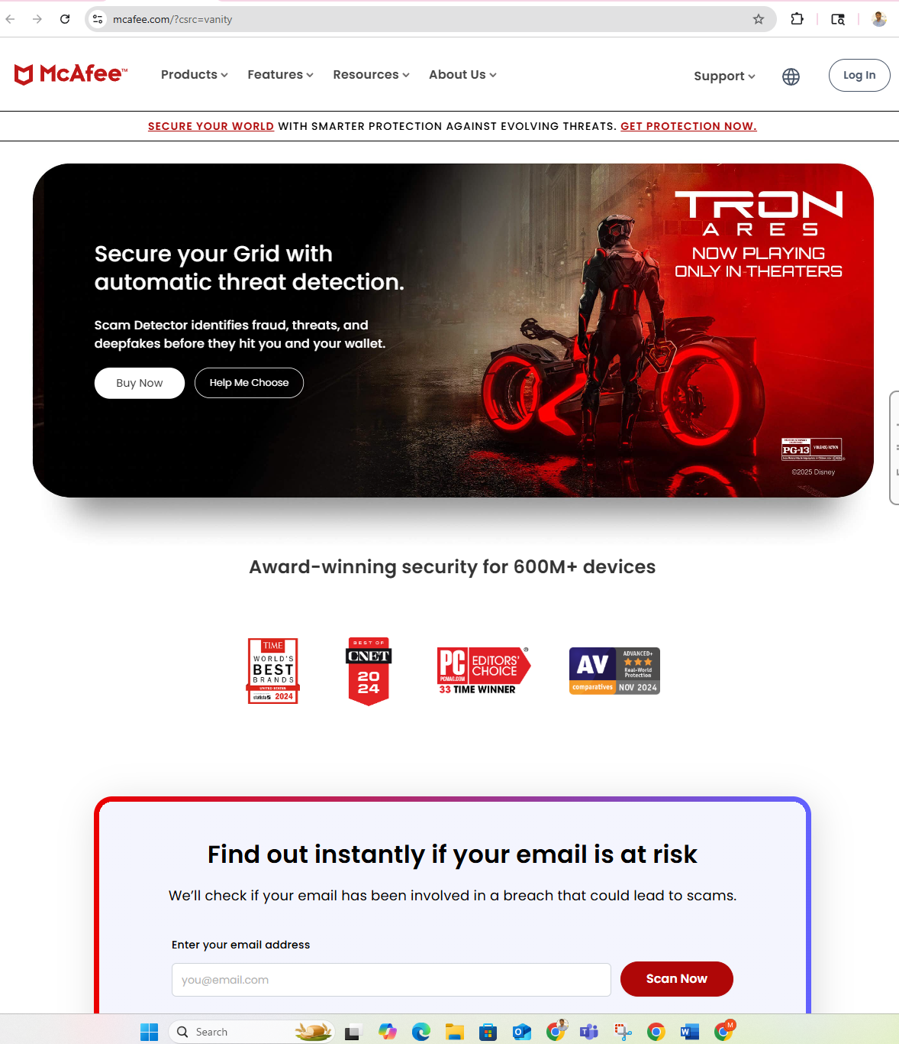
The McAfee Threat Center provides links to McAfee Labs Threat Reports, real-time malware dashboards, and expert analyses of the latest cybersecurity threats. It highlights current malware families, ransomware trends, and global vulnerability alerts.
Step 5: Locate the Latest Cybersecurity Threats List
After scrolling down the McAfee Threat Center homepage, I found the "Latest Cybersecurity Threats" section. This area lists the newest malware families and cyberattacks identified by McAfee's research team. It is regularly updated and used by cybersecurity professionals to track active viruses and worms.
Step 6: Five Most Recent Viruses or Worms
Based on information shown on the McAfee Threat Center at the time of research
SpyLoan Malware (Android)
- A new Android banking Trojan disguised as loan apps.
- Steals SMS messages, contact lists, and personal data to perform financial fraud.
Smishing SMS Campaigns
- SMS-based phishing attacks that trick users into clicking malicious links.
- Commonly used to steal online-banking credentials and install spyware apps.
Conti Ransomware Variants
- A persistent ransomware family targeting corporate networks.
- Encrypts files and demands cryptocurrency ransom; newer variants use double extortion tactics.
Mirai IoT Botnet Family
- Malware that infects Internet-of-Things devices and uses them in large-scale DDoS attacks.
- Continues to evolve with new variants exploiting router and camera vulnerabilities.
RedLine Stealer Data-Exfiltration Tool
- A credential-stealing malware that collects saved passwords, browser cookies, and cryptocurrency wallet data.
- Sold on underground forums and frequently bundled with fake software installers.

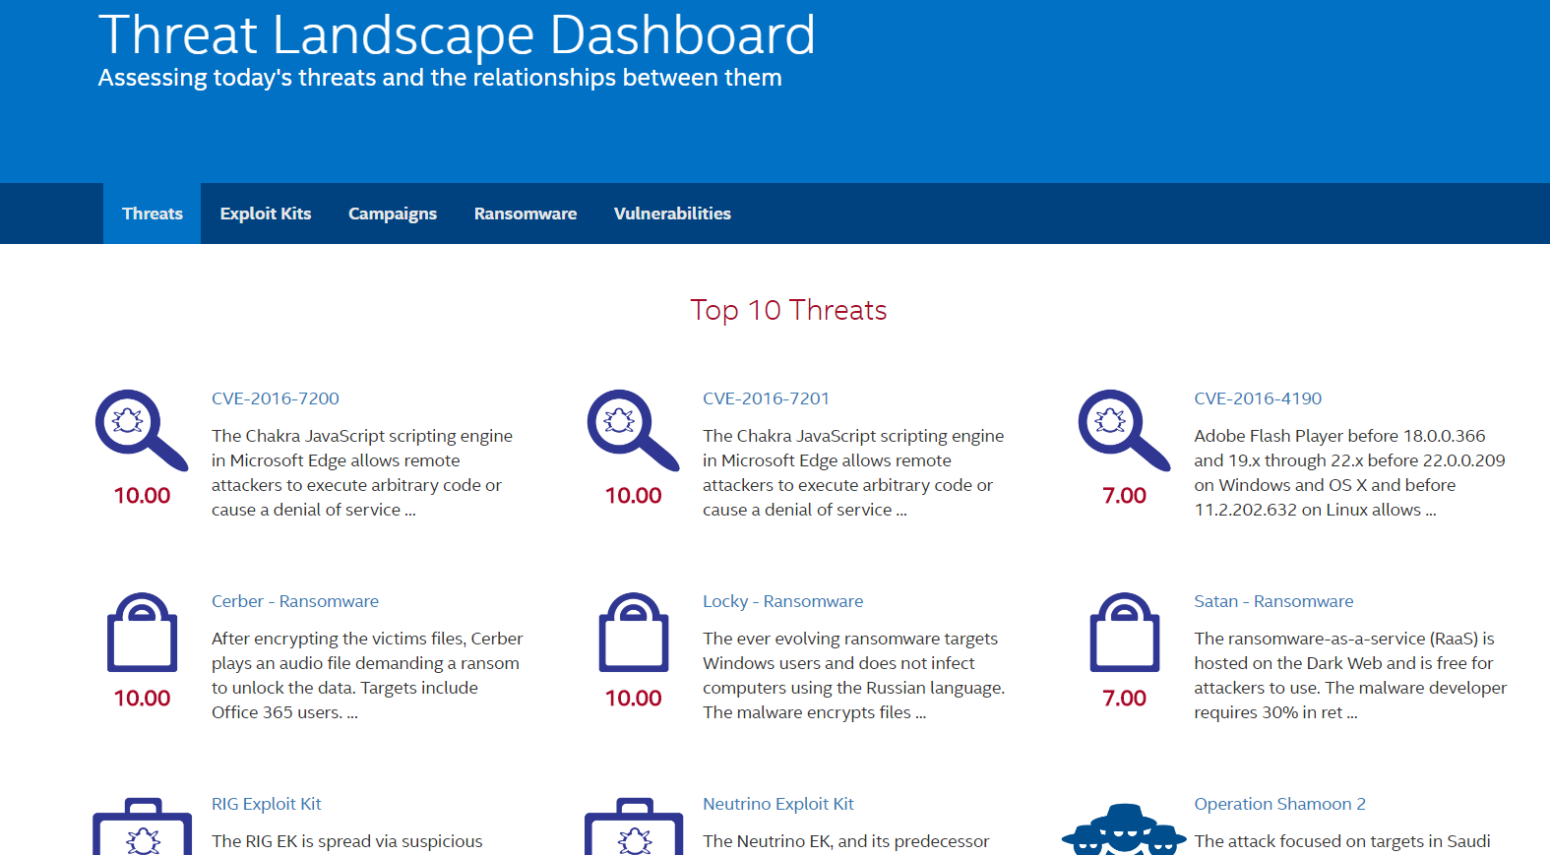
Step 7: Analysis of One Malware: SpyLoan Apps (Android)
SpyLoan is a family of malicious Android apps that disguise themselves as legitimate loan or finance applications. Once installed, these apps request excessive permissions—such as access to contacts, photos, and storage—and then secretly collect and transmit sensitive user data. Some victims have reported extortion and blackmail attempts after installation.
Countries Most Affected:
SpyLoan campaigns have spread globally, with millions of downloads reported on the Google Play Store and third-party sites. High infection rates appear in regions where online micro-loan apps are popular, including South Asia, Africa, and parts of Europe.
Techniques Used to Infect Systems:
- Masquerades as a financial or loan service app to gain trust
- Abuses Android permission requests to exfiltrate contacts, images, and personal data
- Operates stealthily in the background, transmitting data to remote servers
- May use intimidation tactics or social engineering to pressure users

Solutions and Protection Measures:
Method | Description
Download only from trusted app stores | Avoid installing apps from unknown sources (APKs).
Check permissions carefully | Reject requests for unnecessary access to contacts or storage.
Use mobile security apps | Install tools like McAfee Mobile Security or Malwarebytes.
Keep OS and apps updated | Apply the latest security patches.
Verify developer and reviews | Check authenticity of publisher and user feedback.
Monitor device behavior | Watch for battery drain or unusual data usage.

Step 8: Conclusion
The rise of advanced ransomware such as Ryuk and deceptive mobile malware like SpyLoan demonstrates how quickly cyber threats are evolving. Attackers continue to use social engineering, fake applications, and multi-stage payloads to target both organizations and individuals.
To combat these threats, cybersecurity professionals must stay continuously informed through reliable intelligence sources such as McAfee Labs, CVE MITRE, and US-CERT. Regular security training, implementation of layered defense mechanisms, and responsible user behavior are the most effective ways to reduce risk. Maintaining awareness and proactive defense measures ensures stronger resilience against modern malware and emerging digital attacks.

Activity 3-2: Identifying Macro Viruses
Step 1: Open Virus Bulletin Article
I opened the Virus Bulletin article VBA is not dead (Gabor Szappanos), as instructed, at virusbulletin.com/virusbulletin/2014/07/vba-not-dead.
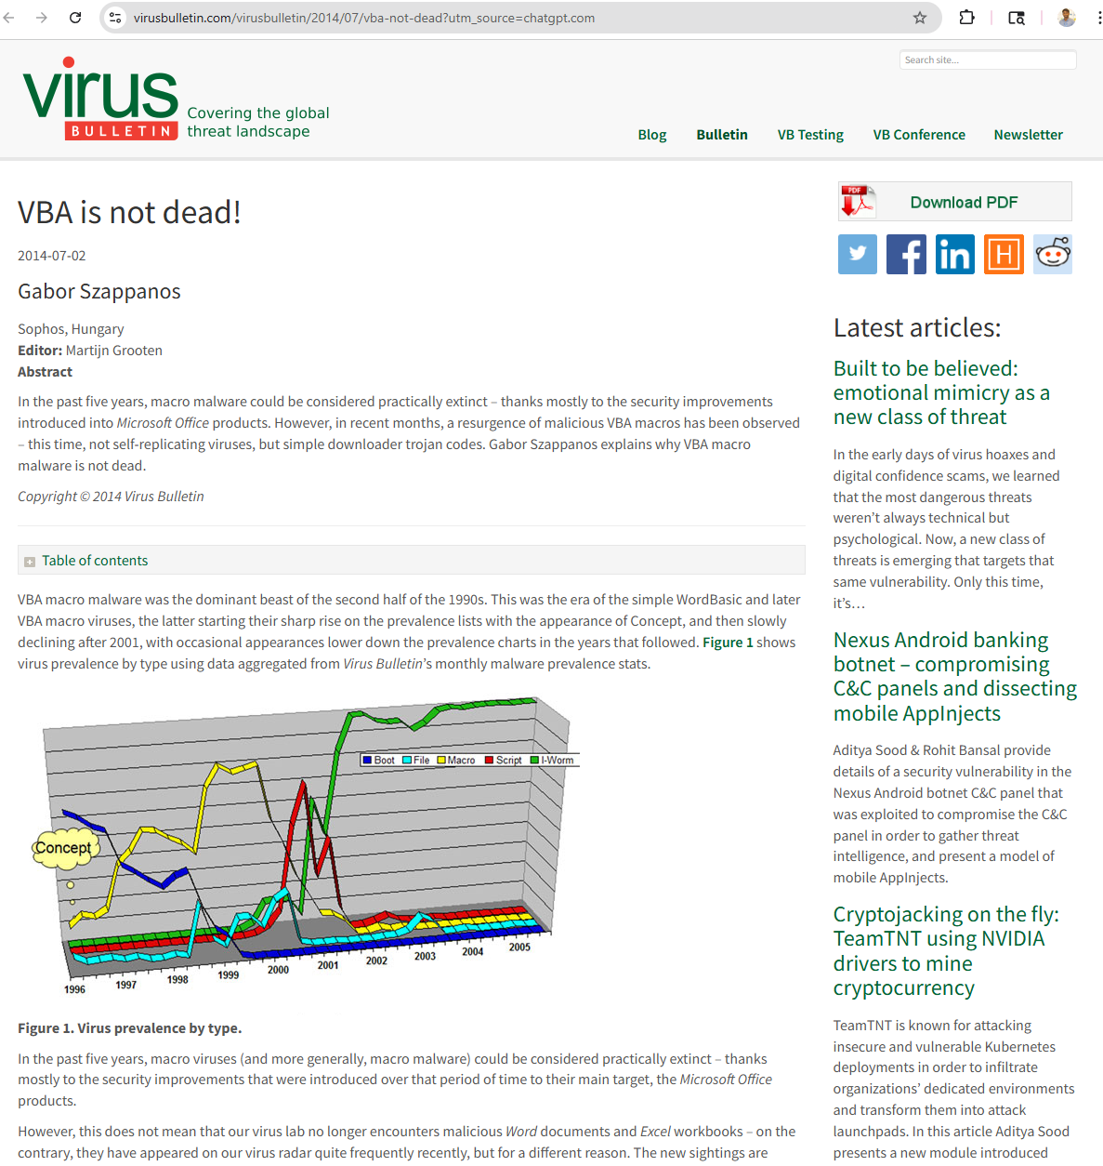

Step 2: Speculation on why macro virus usage increased since 2012
The Decline (2001-2006)
From 2001 to 2006, macro virus activity experienced a major drop, primarily due to security improvements introduced in Microsoft Office products. Microsoft hardened automatic macro execution, making it much more difficult for macro viruses to spread and execute without user intervention.
The Resurgence (Post-2012)
Despite these security improvements, macro virus usage has increased significantly since 2012 due to several interconnected factors:
1. Shift in Attack Strategy
The new wave represents a fundamental change in tactics. Rather than self-replicating viruses, attackers now use simple downloader Trojan codes. These macro-enabled documents serve as initial access vectors to deliver more sophisticated payloads like ransomware (Emotet, TrickBot, Ryuk) and information stealers.
2. Social Engineering Success
Since Microsoft blocked automatic macro execution, attackers adapted by developing sophisticated social engineering techniques to trick users into manually enabling macros. They create convincing, urgent-looking documents that prompt users to Enable Content or Enable Editing, exploiting human psychology rather than technical vulnerabilities.
3. User Complacency
After years of relative safety from macro threats, both users and organizations became less vigilant. Many users, especially those who legitimately use macros in their work, developed habits of enabling macros without careful scrutiny when prompted by seemingly legitimate documents.
4. High Return on Investment for Attackers
Simple VBA downloaders proved to be:
- Easy to craft and modify
- Difficult to detect initially
- Highly effective at bypassing security when users enable macros
- Perfect for delivering targeted, high-value payloads for financial gain
5. Evolution to Targeted Attacks
Instead of mass-spreading viruses, modern macro malware focuses on targeted attacks with specific objectives, making them more profitable and harder to detect than their predecessors.
Step 3: How Word documents and Excel spreadsheets are designed to trick users into running macros
Malware authors use sophisticated social engineering techniques to manipulate document content and convince users to enable macro execution. These tactics exploit human psychology and trust rather than technical vulnerabilities:
Common Social Engineering Techniques:
1. Blurred or Hidden Content with Instructions
Documents display blurred or partially visible content such as invoices, reports, or important information with clear, step-by-step instructions and arrows pointing exactly where to click Enable Content or Enable Macros. Users are led to believe enabling macros will reveal the full document.
2. Fake Warnings and Protection Claims
Documents present official-looking messages claiming:
- This document is protected - enable macros to view
- Content is confidential - enable editing to access
- Macros required to display document correctly
These messages mimic legitimate Office security features, reducing user suspicion.
3. Urgent Business Context
Attackers create urgency using familiar business scenarios:
- Invoice notifications requiring immediate payment
- Shipping/delivery confirmations needing verification
- HR documents requiring employee action
- Transaction reports marked time-sensitive
4. Exploitation of Familiar Formats
Documents are designed to look like legitimate business correspondence invoices, shipping notices, HR forms, financial reports that recipients expect to receive, significantly lowering suspicion.
5. Minimalist or Vague Messaging
Some documents use:
- Basic, cryptic messages that spark curiosity
- Esoteric or vague content that encourages users to enable macros out of curiosity
- Minimal design with no specific hints, leaving everything to user imagination
6. Technical Obfuscation
Advanced attacks may:
- Hide or obfuscate macro security warnings
- Use alternative mechanisms (DDE, Excel 4.0 macros) to bypass simple protections
- Exploit default Office prompts in ways that make enabling macros seem routine

Step 4: Recent malware that has used macro viruses (from "Final Payload" section)
The downloaded payloads demonstrated a wide range of ordinary crimeware, including Zeus-related AutoIt executables, a DotNET injector, and old-fashioned RATs like Simda.
Specifically mentioned:
- Zeus variants: Banking trojans designed to steal financial information
- DotNET injector: Malware that injects malicious code into legitimate processes
- Simda RAT: A Remote Access Trojan allowing attackers to control infected computers
Notable Recent Macro-Based Malware Campaigns:
Emotet
Recent campaigns using VBA and Excel macros as initial loaders to deliver banking trojans and ransomware payloads
Locky
Ransomware historically delivered through Office documents with macros during its active periods
Dridex
Banking trojan campaigns that extensively used Word and Excel documents with macros as delivery mechanisms
TrickBot
Often delivered via macro-enabled documents, used for banking fraud and as a ransomware dropper
Various Downloader Families
Modern VBA attackers commonly use simple downloader code that fetches larger, more sophisticated payloads after initial macro execution
Step 5: Use Google to search for how to create a macro virus. Did you locate any sites or videos with instructions on creating a macro virus?
Yes, a Google search for "how to create a macro virus" returns multiple types of results:
1. Educational and Historical Resources
- Security archives containing historical tutorials (such as "Neophyte's Macro Virus Tutorial") that explain the technical process from an educational perspective
- Academic and research documentation about macro virus structure and functionality
2. General Information Sites
- Wikipedia and cybersecurity sites providing general information about how macro viruses work
- Technical documentation focused on macro virus analysis and detection
3. Legitimate VBA Programming Resources
- Tutorials on creating Office macros for legitimate automation purposes
- Microsoft documentation on VBA programming
4. Potentially Malicious Content
- Some open forums and less reputable sites contain step-by-step malicious techniques
- Various videos demonstrating macro creation both legitimate and potentially harmful
Important Considerations:
Ethical and Legal Warning: Creating or distributing macro viruses is illegal and unethical. These resources exist primarily for:
- Security research and analysis
- Educational purposes to understand threats
- Legitimate VBA programming education
Why This Matters: The widespread availability of such information combined with the low technical barrier to entry is one reason macro malware remains a persistent threat. Attackers can easily find and adapt techniques, which is why social engineering combined with simple VBA code continues to be effective.

Step 6: After reviewing tutorials: Is creating a macro virus difficult or easy?
Based on the tutorial information and security research, creating a basic macro virus appears to be relatively easy, which is a significant security concern.
Why It's Easy:
1. Built-in Tools Available
No special software is required attackers can use the macro functionality built directly into Microsoft Office applications.
2. Simple Programming Language
- Macro viruses use VBA (Visual Basic for Applications), which is a simplified version of Visual Basic
- The Virus Bulletin research noted that modern VBA trojans are very simplistic and didn't stretch the limits of the language.
- Many benign automation tasks use the same language and similar techniques
3. Automatic Execution Functions
The macro code structure uses simple Auto_Open() and AutoOpen functions to execute automatically when documents are opened, requiring minimal coding knowledge.
4. Template Reuse and Modification
Attackers simply keep modifying previous versions by:
- Adding new social engineering content
- Occasionally changing the macro code slightly
- Reusing successful formats
5. Low Technical Barrier
For a basic proof-of-concept or simple downloader that runs commands or fetches a payload, minimal VBA knowledge is sufficient. This low barrier to entry is precisely why macro malware remains popular among attackers.
Important Distinction:
Basic vs. Sophisticated Malware:
- Basic macro virus: Easy to create simple VBA downloader or command executor
- Effective criminal campaign: Much more difficult requires:
  - Payload obfuscation and encryption
  - Evasion of modern security measures
  - Persistence mechanisms
  - Command and control (C2) infrastructure
  - Lateral movement capabilities
  - Backend operational infrastructure
Modern sophisticated campaigns (Emotet, TrickBot, ransomware families) combine the simple VBA loader with advanced backend tools, extensive social engineering, and professional criminal tradecraft.

Activity 3-3: Analyzing the Stuxnet Worm
Step 1 & Step 2
I opened my browser and went to google.com, then searched for “Stuxnet Dossier” to find detailed technical analyses (such as the W32.Stuxnet Dossier).

Step 3: What vulnerability did the worm use to propagate itself?
Steps 1 & 2
I opened my browser and went to google.com, then searched for Stuxnet Dossier to find detailed technical analyses such as the W32.Stuxnet Dossier from Symantec.
Step 3: What vulnerability did the worm use to propagate itself?
Stuxnet used an unprecedented multiple vulnerability approach, exploiting several zero-day vulnerabilities simultaneously to propagate itself:
Primary Propagation Vulnerabilities:
1. Windows LNK/Shell Vulnerability (MS10-046 / CVE-2010-2568) - PRIMARY METHOD
This was one of the key propagation vulnerabilities. The flaw in how Windows handled shortcut (.LNK) files allowed arbitrary code execution when Windows Explorer simply displayed a specially crafted shortcut icon. This required no user interactionmerely viewing the folder containing the malicious shortcut would trigger the exploit. This vulnerability was particularly effective for USB-based propagation.
2. Print Spooler Service Vulnerability (MS10-061 / CVE-2010-2729)
A remote code execution vulnerability used to spread through local area networks (LANs) with shared printers, allowing the worm to propagate across networked systems.
3. Server Service Vulnerability (MS08-067)
Used for propagating through SMB network shares, allowing Stuxnet to copy itself to remote computers over the network.
4. Windows Task Scheduler and Privilege Escalation Vulnerabilities
Multiple privilege escalation bugs (including CVE-2010-3888 and CVE-2010-2743) were used to gain elevated system privileges once installed.
5. WinCC Hard-coded Password (CVE-2010-2772)
Siemens Simatic WinCC and PCS 7 SCADA systems used a hard-coded database password, which allowed Stuxnet to access the back-end database and gain privileges on industrial control systems.
Propagation Methods:
Stuxnet propagated through:
- USB removable media (using the LNK exploit and earlier versions using autorun.inf)
- Network shares over LANs
- Peer-to-peer updates within infected networks
- WinCC database servers using default credentials
Significance:
Stuxnet's use of four zero-day vulnerabilities was highly unusual and demonstrated significant resources and sophistication. Most malware uses one or perhaps two exploits; Stuxnet's use of multiple zero-days ensured maximum propagation capability across different scenarios and network configurations.
Step 4: Did the worm seem to target specific countries?
Yes, Stuxnet clearly and deliberately targeted Iran.
Geographic Distribution:
- Iran: Approximately 60% of all infections over 60,000 out of 100,000 total infected computers by end of 2010.
- Secondary infections: Indonesia, India, Pakistan, Australia, United Kingdom, United States, and others
- Total reach: Over 100,000 hosts across 155 countries
Evidence of Targeted Attack:
The concentration of infections in Iran strongly indicates this was the primary and intentional target where infections were initially seeded. The infections in other countries were likely collateral damage unintentional side-effects of the worm's promiscuous initial propagation methodology.

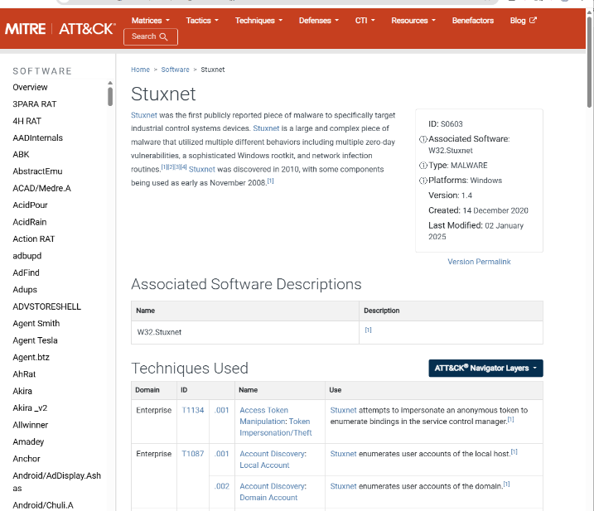
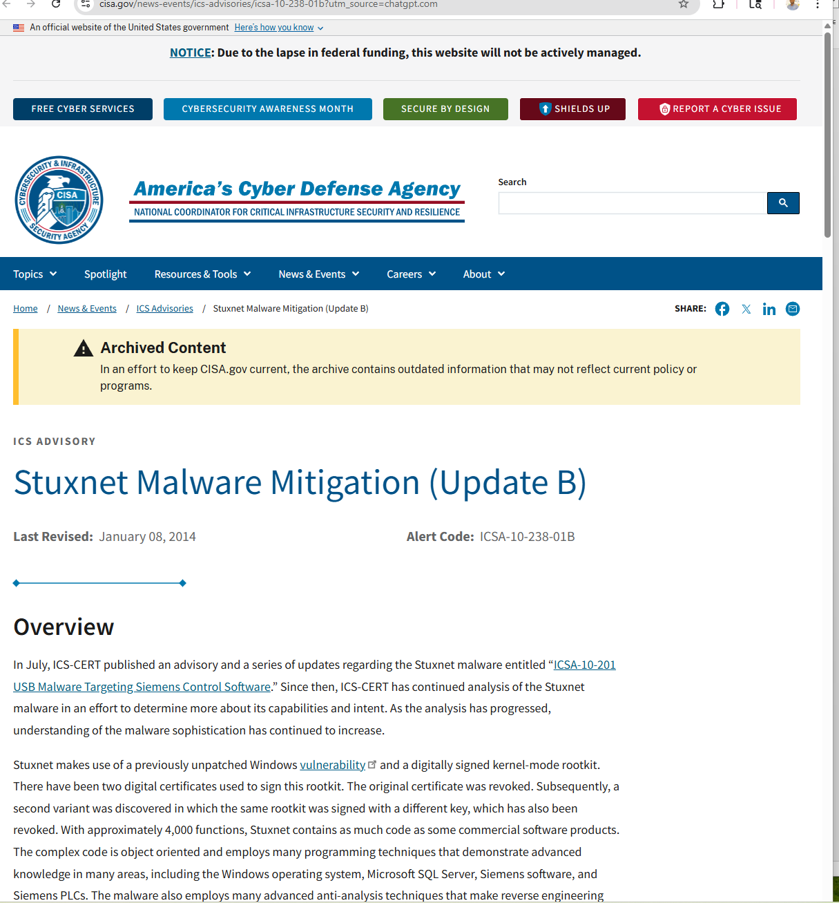

Physical Damage:
Importantly, no physical damage was reported outside of Iran, further confirming the targeted nature of the attack. The worm's payload was designed to activate only under very specific conditions found in Iranian nuclear facilities.

Step 5: Did the worm target specific systems? If so, how?
Yes, Stuxnet was extraordinarily specific in its targeting, demonstrating unprecedented precision for malware.
Target Systems:
Stuxnet specifically targeted:
- Siemens Supervisory Control and Data Acquisition (SCADA) systems
- Siemens Step 7 software used to program Programmable Logic Controllers (PLCs)
- Specific industrial frequency converter drives made by manufacturers in Finland Vacon and Iran Fararo Paya.
Multi-Stage Targeting Process:
Stage 1: Software Detection
Stuxnet searched each infected PC for signs of Siemens Step 7 software, which industrial computers use to automate and monitor electro-magnetic equipment.
Stage 2: Hardware Configuration Verification
The worm looked for SCADA systems connected to frequency-converter drives programmed to run motors at very specific high speeds (characteristic of uranium enrichment centrifuges).
Stage 3: PLC Identification
Stuxnet accessed PLCs and verified the specific CPU type:
- Model 6ES7-315-2
- Model 6ES7-417
Stage 4: Field Device Verification
The worm checked what field devices were connected by reading the PLC's system data blocks, specifically looking for:
- Vacon frequency drive converters (Finland)
- Fararo Paya frequency drive converters (Iran)
Stage 5: Payload Activation
Only if all conditions were met would Stuxnet:
- Record the frequency configuration data
- Begin intercepting and altering commands to the frequency converters
- Manipulate centrifuge speeds to cause physical damage while hiding this activity from operators
Dormancy Feature:
If Stuxnet did not find the specific software-hardware configuration, the program would lie dormant and cause no harm. This design minimized collateral damage and detection risk.
Ultimate Target:
This precise combination of requirements indicated that the likely targets were:
- Natanz uranium-enrichment plant (primary target)
- Bushehr nuclear reactor (possible secondary target)
The worm successfully infected at least 14 industrial sites in Iran, including uranium-enrichment facilities, and caused fast-spinning centrifuges to tear themselves apart, setting back Iran's nuclear program.

Step 6 – Browser Left Open
I left my web browser open for the next activity, as instructed.

Conclusion
Stuxnet represents a watershed moment in cyber warfare and malware development. Its key characteristics include:
- Unprecedented sophistication: Use of four zero-day vulnerabilities demonstrated nation-state level resources
- Surgical precision: Multi-stage targeting system ensured only specific industrial systems were affected
- Physical impact: First known malware to cause significant physical destruction of industrial equipment
- Geopolitical implications: Demonstrated that cyber weapons could effectively sabotage physical infrastructure
Security Implications:
As security professionals, Stuxnet teaches us that:
- Critical infrastructure and industrial control systems are vulnerable to sophisticated cyber attacks
- Air-gapped systems (not connected to the internet) are not immune to infection (USB propagation)
- Nation-state actors have both the capability and willingness to develop cyber weapons
- Defense-in-depth strategies are essential, as Stuxnet defeated multiple security layers
- Monitoring for anomalous behavior in industrial systems is critical, as Stuxnet hid its activities from operators
The Stuxnet attack fundamentally changed how we think about cybersecurity, particularly regarding industrial control systems and critical infrastructure protection.

Activity 3-4: Identifying Spyware
Step 1 – Search for “spyware”
I opened my web browser and went to www.google.com. I typed "spyware" in the search box and pressed Enter.
Step 2: List some of your search results
When searching for spyware on Google, typical search results include:
- What Is Spyware? Definition, Types, and Prevention | Splunk
- What Is Spyware? Definition, Types And Protection | Fortinet
- What is Spyware? | Definition from TechTarget
- What is Spyware and How Do You Check For It? | Security.org
- What Is Spyware? - Dataconomy
- What Is Spyware, Who Can Be Attacked, and How to Prevent It | Avast
- Recognizing and Avoiding Spyware | CISA
- What Is Spyware? Types, Risks, and Prevention Tips | SentinelOne

Step 3: Description of spyware based on search results

Definition and Overview

Spyware is malicious software (malware) that enters a user's computer, gathers data from the device and user, and sends it to third parties without their consent. It is installed on a computing device without the end user's knowledge, invades the device, steals sensitive information and internet usage data, and relays it to advertisers, data firms, or external users. Any software can be classified as spyware if it is downloaded without the user's authorization.

How Spyware Works

Once installed, spyware operates in the background, monitoring and collecting information without the user's awareness. It:
- Monitors internet activity and browsing behavior
- Tracks login credentials and passwords
- Spies on sensitive personal and financial information
- Records keystrokes and user actions
- Transmits collected data to remote third parties

Primary Goals and Targets

The primary goal of spyware is usually to obtain:
- Credit card numbers
- Banking information and account credentials
- Personal passwords and login details
- Browsing habits and online behavior
- Personal identification information

This stolen data can leave individuals and businesses vulnerable to identity theft, financial fraud, and data breaches.

Types of Spyware

Spyware comes in various forms, including:
- Adware - Monitors users' browsing habits and sells their data to advertisers
- Infostealers - Collects specific data and files from infected devices
- Keyloggers - Records every keystroke made by the user
- Rootkits - Deeply infiltrates devices at the system level for hidden access
- System Monitors - Tracks all user activity on the device
- Tracking Cookies - Follows and records online activity across websites

Impact on Users and Systems

Beyond privacy violations, spyware can:
- Degrade system performance and slow down devices
- Consume system resources
- Create security vulnerabilities for additional attacks
- Enable ongoing surveillance of user activities
- Facilitate data breaches in business environments

Privacy and Ethical Concerns

Spyware is controversial because, even when installed for relatively innocuous reasons (such as parental monitoring or employee tracking), it violates the end user's privacy and has significant potential to be abused. The unauthorized nature of its installation and data collection makes it both a legal and ethical issue.

Prevalence

Spyware is one of the most common threats to internet users today, affecting both individual consumers and organizations. Its widespread nature and evolving sophistication make it a persistent cybersecurity challenge.
Step 4 – Visit CISA Website
Next, I went to us-cert.cisa.gov (the U.S. Cybersecurity & Infrastructure Security Agency).
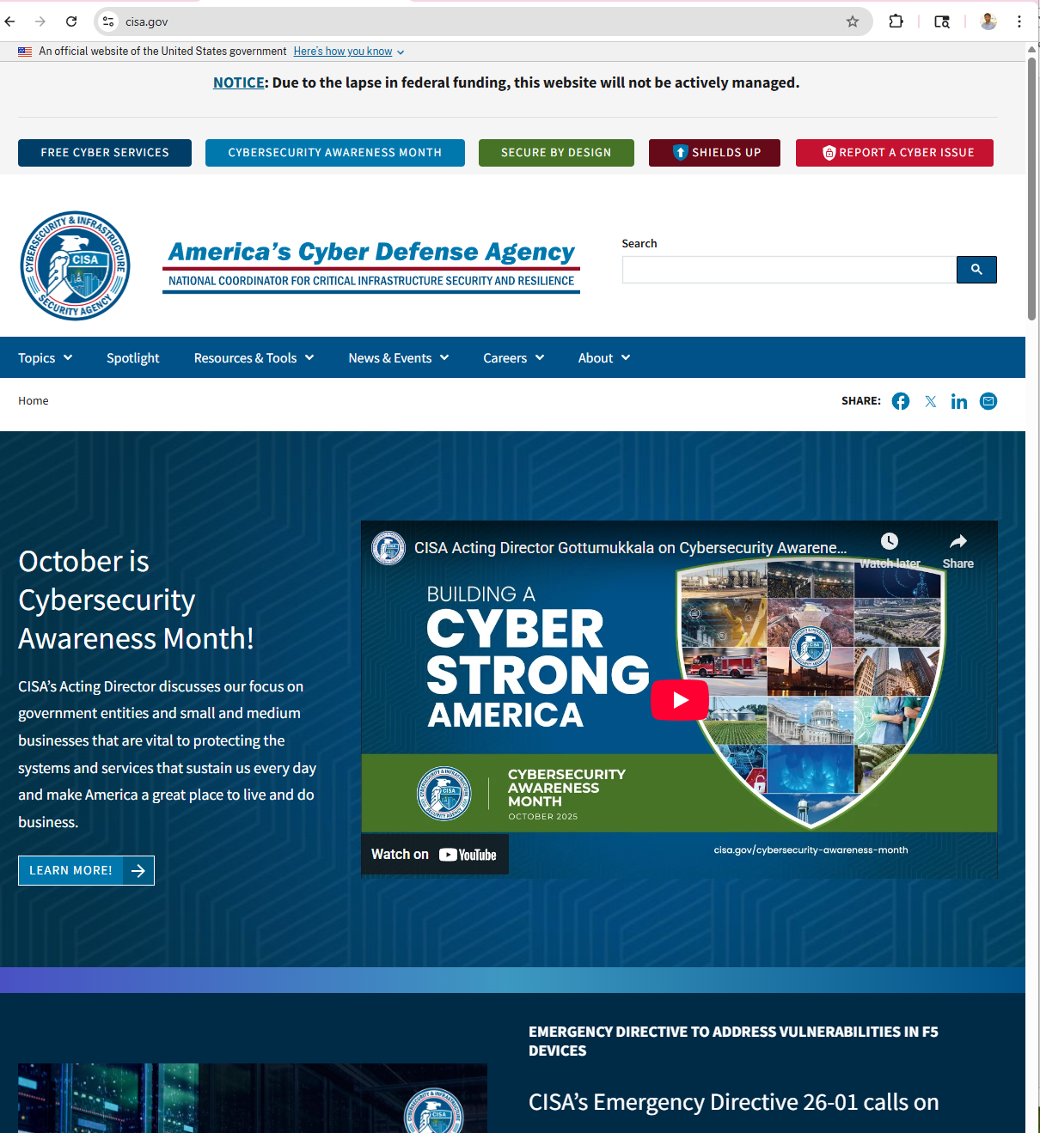

Step 5 – Search for “spyware” on CISA
On the CISA site’s search box, I entered spyware and pressed Enter.

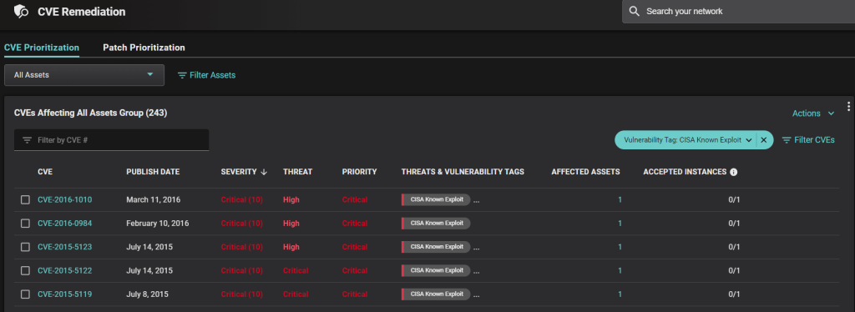
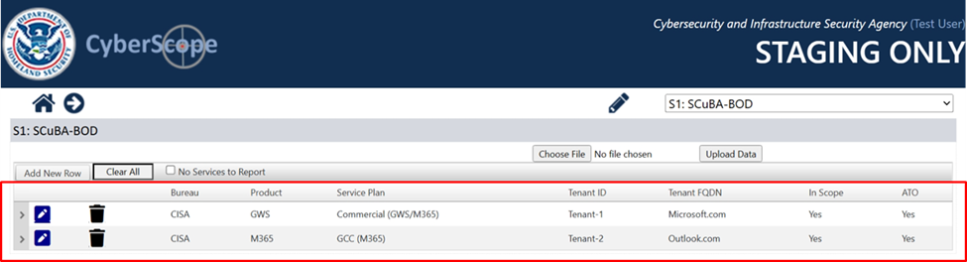

Step 6: Brief description outlining the CISA Security Tip sections
Based on the CISA article "Recognizing and Avoiding Spyware," here is a comprehensive outline of the key sections:
How Do You Know? (Recognizing Spyware)
System Performance Indicators:
- Your computer suddenly becomes very slow or sluggish when opening programs or processing tasks due to extra processing overhead from spyware
- Unusual network traffic or bandwidth usage
- Random Windows error messages begin to appear
- Certain keys fail to work in your browser
Visual/Interface Changes:
- Endless pop-up windows appear constantly
- You are redirected to websites other than the one you typed into your browser
- New, unexpected toolbars appear in your web browser
- New, unexpected icons appear in the task tray at the bottom of your screen
- Your browser's home page suddenly changes without your permission
- The search engine your browser opens when you click "search" has been changed
Account and Security Indicators:
- Unusual account activity or unauthorized access
- Software programs you didn't install appear on your system
Privacy Implications:
Important privacy concerns exist regarding what information is being gathered, who is receiving it, and how it is being used.

How Can You Prevent? (Prevention Strategies)
Software Protection:
- Install, update, and run reputable anti-malware/anti-spyware tools regularly
- Keep your operating system and all software patched and up to date with the latest security updates
Safe Browsing Habits:
- Don't click on links within pop-up windows - Because pop-up windows are often a product of spyware, clicking on them may install spyware software; instead, close pop-ups by clicking the "X" icon in the titlebar
- Avoid clicking suspicious links or attachments in emails or on websites
- Download only from trusted sources - Don't download programs from sites you don't trust
User Behavior Best Practices:
- Choose "no" when asked unexpected questions - Be wary of unexpected dialog boxes asking whether you want to run a particular program; always select no or cancel, or close the dialog box by clicking the X icon
- Be wary of free downloadable software Customized toolbars or other features may expose your computer to spyware
- Don't follow email links claiming to offer anti-spyware software Like email viruses, these links may actually install the spyware they claim to eliminate
Browser Configuration:
- Adjust your browser preferences to limit pop-up windows and cookies Pop-ups are often generated by scripting or active content; certain types of cookies are considered spyware because they reveal browsing history

How Do You Remove? (Removal Strategies)
Primary Removal Steps:
- Run a full scan with anti-virus software
  - Some anti-virus software will find and remove spyware
  - Note: It may not find spyware during real-time monitoring
  - Set your anti-virus software to prompt you to run full scans periodically
- Use legitimate anti-spyware products
  - Run specialized products designed specifically to remove spyware
  - Run full system scans and quarantine or remove identified threats
  - Popular products mentioned include:
    - Lavasoft's Ad-Aware
    - Microsoft's Windows Defender
    - Webroot's SpySweeper
    - Spybot Search and Destroy
Advanced Removal (If Standard Methods Fail):
- System Reinstallation (Last Resort)
  - Backup your important data
  - Wipe/reinstall the operating system
  - Restore from clean backups
Important Compatibility Note:
- Ensure anti-virus and anti-spyware software are compatible Take a phased approach to installing security software to avoid unintentionally introducing system conflicts
Step 7: Leave Your Browser Open
I left my web browser open for the next activity, as instructed.

Activity 3-5: Researching Software Vulnerabilities
Step 1: Open the US-CERT NCAS page
I opened the US-CERT / CISA NCAS area and navigated to the Vulnerability Bulletins (CISA Vulnerability Bulletin / View Bulletins).
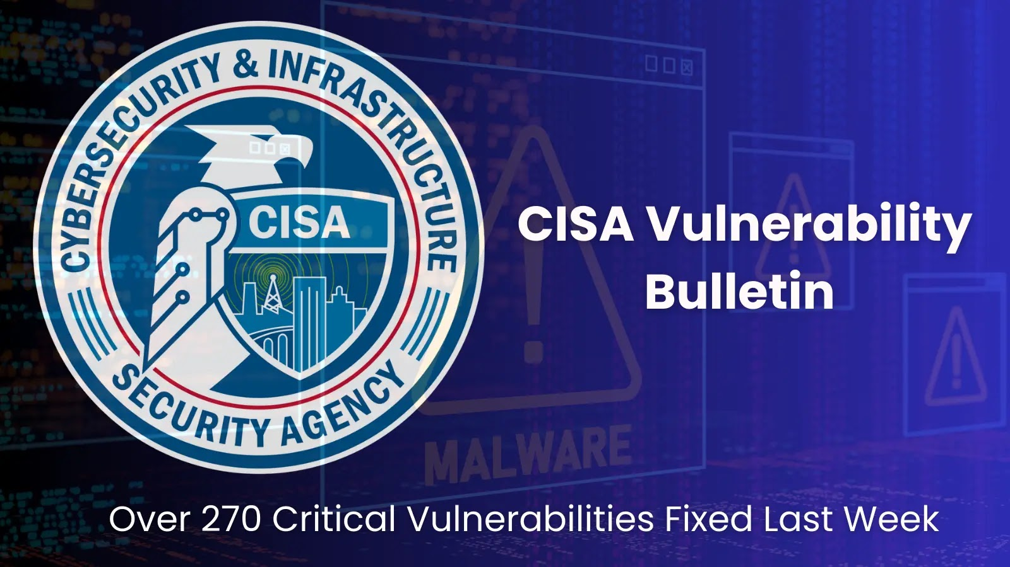

Step 2: View the most recent bulletin
I scrolled the Bulletins list and opened the most recent weekly vulnerability bulletin CISA publishes weekly vulnerability summaries listing CVEs and links to vendor patch/mitigation information. Example recent bulletin listing is the Vulnerability Summary for the Week of August 11, 2025.

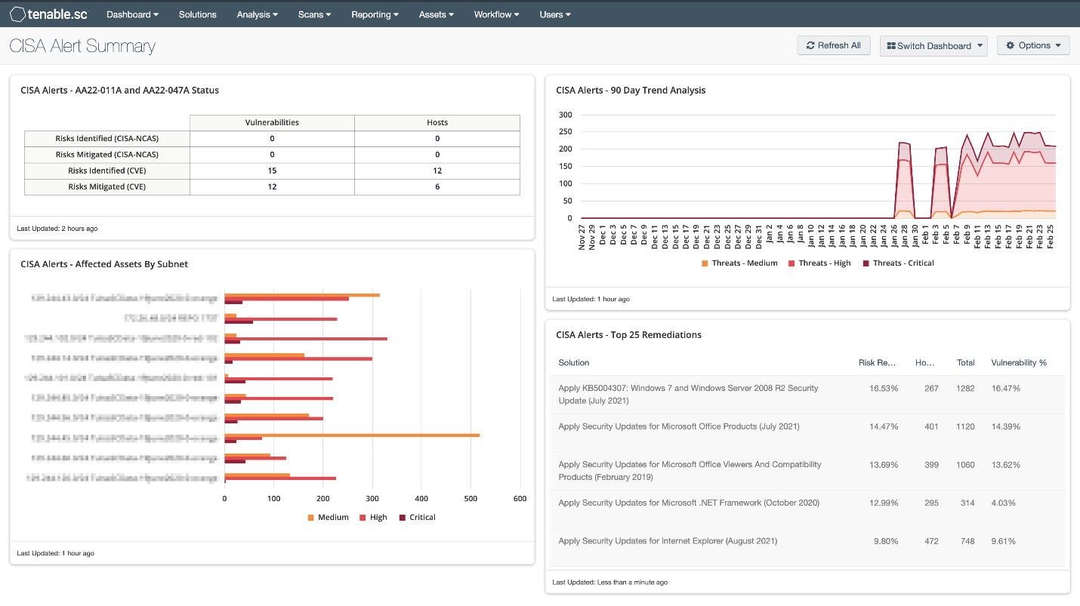

Step 3: Selected Vulnerability Analysis - CVE-2022-4980
I have selected CVE-2022-4980, an authentication bypass vulnerability in General Bytes Crypto Application Server (CAS), for detailed analysis.
Vulnerability Description:
General Bytes Crypto Application Server (CAS) beginning with version 20201208 prior to 20220531.38 (backport) and 20220725.22 (mainline) contains an authentication bypass in the admin web interface. An unauthenticated attacker could invoke the same URL used by the product's default-installation / first-admin creation page and create a new administrative account remotely.
Impact:
By gaining admin privileges, the attacker can change the ATM configuration resulting in redirected funds. The issue was actively exploited in the wild against cloud-hosted and standalone CAS deployments (scanning exposed CAS instances on ports 7777/443), and publicly acknowledged by General Bytes in September 2022.
When customers would deposit or purchase cryptocurrency via the ATM, the funds would instead be siphoned off by the hackers. The attacker modified the crypto settings of two-way machines with his wallet settings and the 'invalid payment address' setting, causing two-way ATMs to start forwarding coins to the attacker's wallet when customers sent coins to the ATM.
Attack Method:
The attackers took advantage of a zero-day vulnerability in the administration interface of the ATMs' Crypto Application Server (CAS). After scanning the Internet for exposed CAS services running on ports 7777 or 443, the attackers exploited the vulnerability to gain administrator access to the ATMs and create a new administrator account
The attacker was able to create an admin user remotely via CAS administrative interface via a URL call on the page that is used for the default installation on the server and creating the first administration.The vulnerability existed since version 2020-12-08, meaning it was present for almost two years before being discovered.
If a customer's system has been exploited because of this vulnerability, I would provide the following recommendations:
- Immediate Actions:
  - Shut down all affected Bitcoin ATMs immediately to prevent further cryptocurrency theft
  - Disconnect the CAS from the internet to stop ongoing unauthorized access
  - Change all administrative credentials including passwords and API keys
  - Review transaction logs to identify all unauthorized transactions and determine the total amount stolen
  - Contact law enforcement and file a cybercrime report with appropriate authorities
- Investigation and Recovery:
  - Audit all administrative accounts to identify any fake admin accounts created by attackers
  - Review ATM configuration settings, particularly the "buy," "sell," and "invalid payment address" settings to ensure they haven't been modified
  - Check all cryptocurrency wallet addresses configured in the system to ensure they belong to legitimate entities
  - Examine access logs to identify the source of the attack and timeline of malicious activity
  - Notify affected customers whose funds may have been redirected to attacker-controlled wallets
- System Hardening:
  - Restore systems from clean backups taken before the compromise (if available)
  - Implement VPN requirements for all CAS administrative access
  - Place CAS servers behind firewalls with strict access controls
  - Enable and enforce multi-factor authentication for all administrative accounts
  - Disable unnecessary ports particularly 7777 and 443 if not required
Prevention Measures:
To prevent exploitation of this vulnerability, organizations should implement the following measures:
- Patching and Updates:
  - Immediately apply security patches: Upgrade to version 20220531.38 or later for backported versions, or version 20220725.22 for mainline versions
  - Establish a patch management program to ensure timely application of security updates
  - Subscribe to General Bytes security advisories to stay informed about vulnerabilities
- Network Security:
  - Implement VPN access only for CAS administrative interfaces
  - Use firewall rules to restrict access to management ports (7777, 443)
  - Avoid hosting CAS servers directly on public cloud services without proper security controls
  - Use network segmentation to isolate ATM management systems from other networks
- Access Controls:
  - Disable or rename default installation pages after initial setup
  - Implement strong authentication requirements for all administrative functions
  - Use principle of least privilege when granting administrative access
  - Regularly audit administrative accounts and remove unused or suspicious accounts
- Monitoring and Detection:
  - Enable comprehensive logging of all administrative actions
  - Implement security monitoring to detect unauthorized account creation
  - Set up alerts for configuration changes to ATM settings
  - Conduct regular security audits of CAS deployments
  - Monitor cryptocurrency wallet transactions for anomalies
- Best Practices:
  - Follow vendor security guidelines for deployment and configuration
  - Conduct regular security assessments and penetration testing
  - Implement defense-in-depth strategies with multiple layers of security
  - Train staff on recognizing and responding to security incidents

Step 4: Exit the web browser
I finished documenting the vulnerability, recommendations, and preventive steps, then closed the browser as requested.

